**Assignment 26.5**

**How many kinds of tables are present in hive and explain the difference between them with a demo.**

There are 2 types of tables in HIVE

1. Managed Table

2. External Table

**Managed Table:**

It is the type of table that are owned and managed by Hive whenever we create an Internal table and load data from HDFS path, the entire data get transferred from HDFS location to hive warehouse location while if we load data from local location a copy of that file will be made in the table directory created. Thus if we use Managed Table the data will be moved from HDFS location to hive warehouse location.

Another thing is that if we use a Managed table and if we delete the table the entire data will be deleted.

Third thing is that if we use a managed Table only the file will be moved but the directory will remain which will be awkward if we use output of a mapreduce.

**Creating managed table employee data:**



**Inserting data into that table by using load command:**

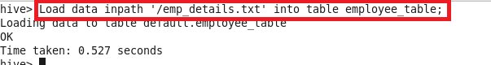

**BEFORE LOADING DATA:**

We can see that the emp_details.txt present

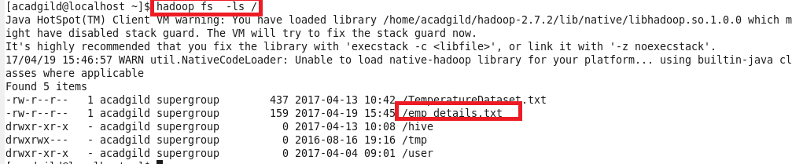

**After loading data**

The data is moved from HDFS location to directory created in table name as shown

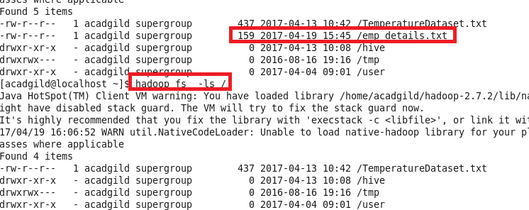

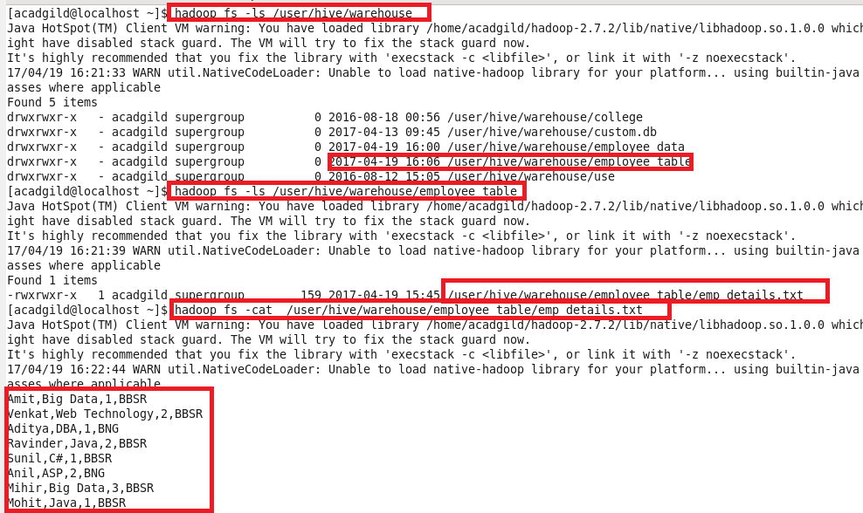

**Drop Table**

On dropping the table the entire data get deleted

**Deleting table**



**Before and after deleting table**

After deleting table the data gets missed

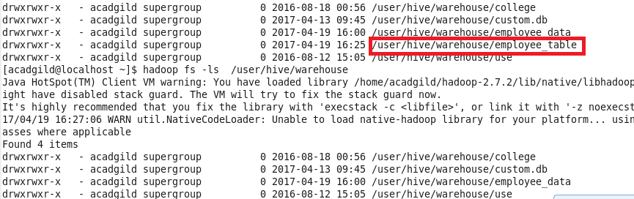

**External Table:**

It is the type of table in which table only contains the metadata but not the actual data but the problem with external table is that since it has only the metadata the data should be available in HDFS and not in local location

I will use the same data for external table.So I will put the file into HDFS

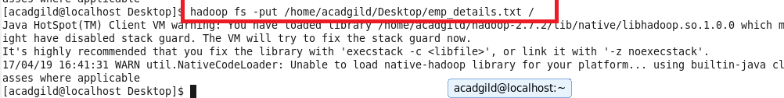

**Creating external Table:**

External table can be created by using external word before Table as shown and loading data by directly giving the location

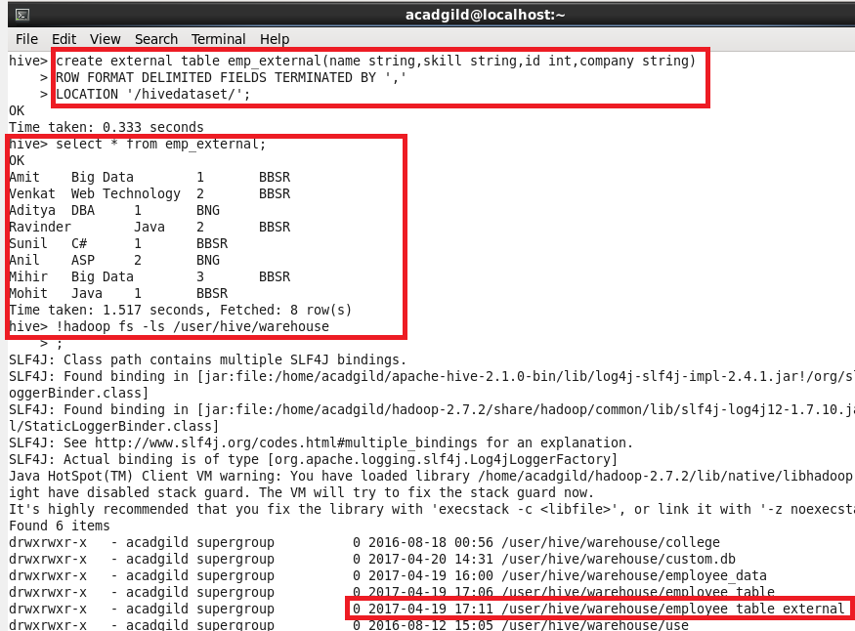

Unlike managed table where file will be moved from HDFS to hive/warehouse here data remains with the parent location

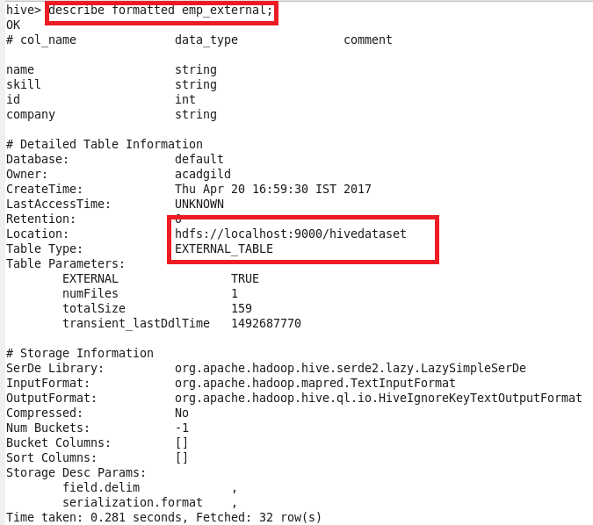

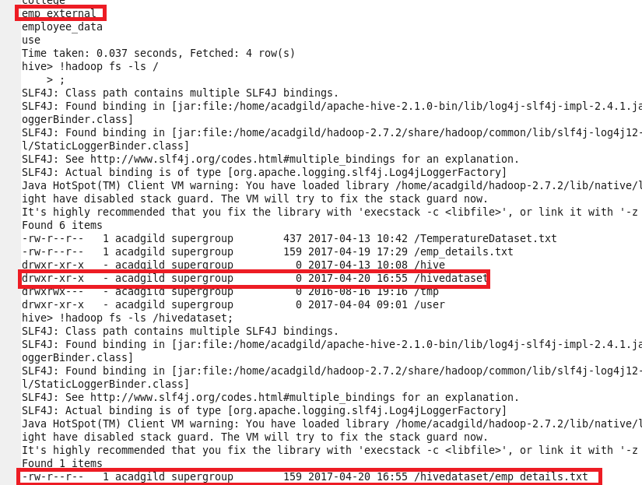

Thus if an External Table is dropped only metadata and the schema gets dropped and the data does not get dropped

